Payment Methods:

Marketplace allows to users to make payment using cryptocurrency Desire Coin.

* **Desire coin:**

Desire is an experimental new digital currency that enables anonymous, instant payments to anyone, anywhere in the world. Desire uses peer-to-peer technology to operate with no central authority: managing transactions and issuing money are carried out collectively by the network. Desire Core is the name of the open source software which enables the use of this currency.

The value of this coin is 0.4$ and has a market cap of $404,490 USD and Volume (24h) $11784 USD.

* **Payment process**:

Every user has his own wallet address that will be generated.   
  
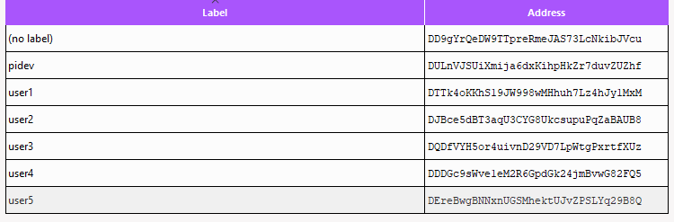

* **Desire Core Wallet:**

Desire core is the software that allows to send, receive and store Desire.

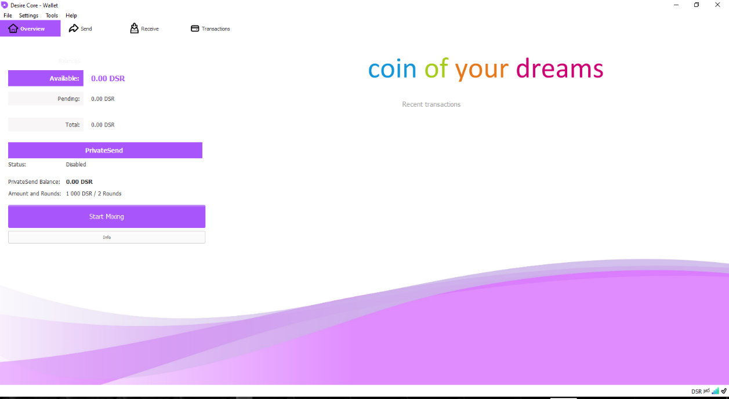

* **API Desire Core RPC:**

**Throw this API we can communicate with the wallet and send request getnewaddress ( "account" ):**   
Generate a new wallet foreach user.

**getbalance ( "account" minconf addlockconf includeWatchonly ):**verify user balance.

**sendtoaddress "desireaddress" amount ( "comment" "comment-to" subtractfeefromamount use_is use_ps ):**

to affect payment and withdraw money from balance.

* **Security:**

#### **The Desire Core RPC afford authentication procedure in order to secure**

-**rpcuser** Should be set to your wallet identifier. This is a 36-character random string which can be found on your wallet login page, or a config file.  
-**rpcpassword** Should be set to your main wallet password. If double encryption is enabled your second password will need to be set using walletpassphrase  
-**rpcport** Should be set to 443 for https:// (when the -rpcssl is provided) or 80 for plain text HTTP://  
-**rpcssl** Set to use a secure connection (Recommended)

